ASSE International
18927 Hickory Creek Drive, Suite 220
Mokena, IL 60448
Phone: (708) 995-3019
E-Mail: staffengineer@asse-plumbing.org • Website: www.asse-plumbing.org

Memorandum

TO: Applicants for ASSE Product Listing
FROM: Tom Palkon, ASSE Executive Director

Congratulations! Your desire to continue or to apply for authorization to display the ASSE Seal is to be commended. The plumbing industry throughout the United States and North America recognizes the Seal as an indication that the product on which it is displayed is reviewed by an unbiased, consensus committee for compliance to criteria based on an applicable product standard.

ASSE International wants to offer its assistance to you in obtaining the Seal. To help speed the application process, it is very important to note that ASSE cannot issue a Seal for a product that has not been tested and evaluated to the applicable product standard as listed in the current edition of the ASSE Certification Scheme Procedure (A-001): https://www.asse-plumbing.org/media/32190/asse_certification_scheme_procedure.pdf. If you have any questions regarding the status of your application, please do not hesitate to contact the Product Listing Team at the ASSE International Office at 18927 Hickory Creek Drive, Suite 220, Mokena, IL 60448 • Phone: (708) 995-3019 • E-Mail staffengineer@asse-plumbing.org

We look forward to working with you in maintaining our motto:

"Prevention Rather Than Cure".

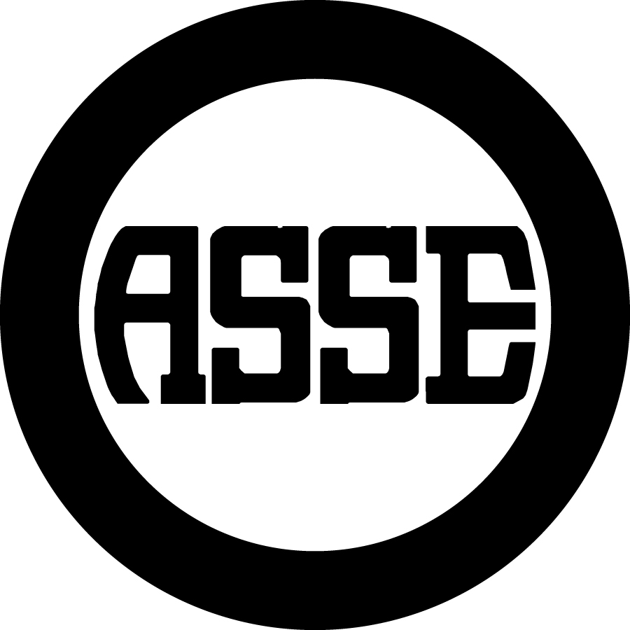
ASSE Product Listing Application and Contract

Product Listing Application Information
The ASSE Seal may be displayed only on or in connection with those products that have been evaluated and found to be in compliance with the applicable standard(s) in accordance with the ASSE Certification Scheme Procedure (A-001) (current edition).
In order to obtain authorization to display the ASSE Seal on a product, the Applicant shall first have its product tested by an ASSE listed testing laboratory for compliance with the applicable standard. The laboratory must complete an approved laboratory evaluation report (test report) for ASSE standards. A list of the approved testing laboratories is attached.
All arrangements for testing the product shall be made directly between the manufacturer and the testing laboratory. Any fees for testing shall be arranged directly between the laboratory and the manufacturer.
Before, during, or after the product has been tested, the Applicant may apply for authorization to display the ASSE Seal or cASSE Seal. The ASSE Product Listing Application and Contract shall be completed and submitted with each new certification to a given standard and revision. At the time the required materials are submitted to the Product Listing Team, one copy of this Product Listing Application and Contract, and the initial model fee, shall be forwarded to the ASSE International Office for processing. Application fees are nonrefundable.
The submitted materials shall include a Bill of Material (BOM) or exploded view showing the assemble of the product of the product(s) and a drawing or diagram showing where the ASSE Seal or cASSE Seal shall be displayed, if approval is granted for ASSE listing.
The initial model and annual renewal fees shall be charged according to the ASSE’s latest fee schedule. To request a copy E-Mail: staffengineer@asse-plumbing.org.
Per the ASSE Certification Scheme Procedure (A-001), an announced or unannounced factory audit shall be conducted yearly for each listing and prior to initial certification for factories not yet audited by ASSE. The audit is conducted by ASSE staff or a contracted auditor. All costs relating to the audit shall be billed by ASSE directly to the listee.
Display of the ASSE Seal or cASSE Seal – The Seal and the standard number shall be permanently marked on or with a permanent label on all ASSE listed product(s) which have received prior, written consent from the ASSE Executive Director. For exemptions, refer to the ASSE Certification Scheme Procedure (A-001). The listee shall not use the certification to bring ASSE into disrepute and not make claims beyond the scope of certification. IAPMO is the sole owner of the ASSE Seal and cASSE Seal. The ASSE Seal is a duly registered certification mark (United States Trademark Reg. No. 2,323,383; Canadian Trademark Reg No. TMA856415).
Prohibition of Display – The ASSE Seal shall not be displayed on any product, advertisement, literature, instruction, packaging or any other printed material until authorization has been received from the ASSE Executive Director.
Display of the ASSE Seal is not a product endorsement. Display of the ASSE Seal or cASSE Seal is confirmation that the product has been submitted to ASSE for evaluation to the applicable standard, been reviewed, and found to be in compliance with the applicable standard and the current edition of the Seal Control Procedures. Any misrepresentations or violations shall be cause for the removal of certification.
Complimentary artwork for printing the ASSE Seal or cASSE Seal are available from ASSE International.
Application Type
Original Equipment Manufacturer (OEM) of models on application. Check the boxes below as required:
Standard Review Accelerated Review Transfer Listing US & Canadian Listing
LEC (Listing Evaluation Criteria) Evaluation Report
Private Label of models cross-listed to existing ASSE seal #
For New Applicants except Private Label Applicants, the following is required:
 Copy of the laboratory evaluation report. (The original copy of the laboratory evaluation report shall be submitted directly from the laboratory to the attention of the Product Listing Coordinator.) This is not applicable for listing transfers from other certification bodies, private label applications, or listings to non-ASSE standards.
 Assembly drawings.
 Individual detail parts drawings of the components of the product with a complete material listing.
 Wetted parts list, if applicable per the standard.
 One copy of a current ISO-9001 Certificate (if applicable)
 If applicable, a list of outsourced processes affecting conformity to the SC Procedures (e.g. gauge calibration)
 For manufacturing facilities not previously audited by ASSE, a copy of the facility’s Quality Control Manual.
 For transfer listings from other certification bodies, the name of the certification body and the certification number.

For Private Label Applicants,
 Complete Private Label Request Form (may request from: staffengineer@asse-plumbing.org.)
For All Applicants, the following is required:
 Installation instructions, specification sheets, maintenance instructions, testing instructions, and spare parts lists.
 A completed and signed Product Listing Application and Contract.
 A drawing of the product/s showing where the ASSE Seal and the applicable standard shall be displayed.
 Fee according to ASSE’s latest fee schedule. To request a copy of ASSE’s latest fee schedule, email staffengineer@asse-plumbing.org..
For Existing Clients only updating their contract
 A completed and signed Product Listing Application and Contract. This contract pertains to all of the listee’s current active certificates, which state the products and scopes of certification.
Product Information
Applicable Standard (only one standard) Revision Year
Brand or Trade Name (if different from mfg.) Existing Seal # (if applicable)
Identification (include number, type, model (or other means of identification for this specific product))

ASSE Approved Testing Laboratory (if applicable)
Date Submitted to laboratory (if applicable)
Contact Information and Locations

Company / Listee:
Company Representative Name:
Address Line 1:
Address Line 2:
City: State/Province: Country: Zip/Postal Code:
Telephone: Fax: E-mail:
Listee Name, if different than representative’s company:
Contact:
Address Line 1:
Address Line 2:
City: State/Province: Country: Zip/Postal Code:
Telephone: Fax: E-mail:
Product Manufacturing Location, if different than listee:
Contact:
Address Line 1:
Address Line 2:
City: State/Province: Country: Zip/Postal Code:
Telephone: Fax: E-mail:
Warehouse Location(s), if different than listee:
Contact:
Address Line 1:
Address Line 2:
City: State/Province: Country: Zip/Postal Code:
Telephone: Fax: E-mail:
Private Label Company name, if applicable:
Contact:
Address Line 1:
Address Line 2:
City: State/Province: Country: Zip/Postal Code:
Telephone: Fax: E-mail:
The Agreement:
I, as a duly authorized representative of (Company), have read and understand the procedures in the current edition of the ASSE Certification Scheme Procedure (A-001). Copies are available (at no cost) upon written request to ASSE or at https://www.asse-plumbing.org/media/32190/asse_certification_scheme_procedure.pdf on the ASSE website. In consideration for its ability to participate in the ASSE Seal program and the license to display the Seal granted hereby, Company agrees to be bound by the ASSE Certification Scheme Procedure (A-001).
ASSE warrants only that the services provided by ASSE pursuant to this Agreement will be provided in good faith. No other representations or warranties are provided by ASSE with respect to its services or this Agreement. Company hereby waives any claim or cause of action against ASSE based on negligence arising out of any actions or failures to act by ASSE in granting, denying, or revoking any listings, except claims based on gross negligence or lack of good faith by ASSE.
In no event shall ASSE be liable to any Company or any other person or entity for any consequential, special, or indirect damages for any claim or cause of action whatsoever, whether based in contract, tort or otherwise. Company agrees to indemnify, defend and hold ASSE and its officers, directors, members, agents, parent and representatives harmless from and against any and all claims, liabilities, losses, damages, costs and expenses, including, but not limited to, attorney’s fees, investigative costs and court costs arising out of, relating to or in connection with (a) Company’s participation in ASSE’s Seal program, including but not limited to statements by Company to third parties relating to Company’s participation in ASSE’s Seal program, and (b) all third party claims relating to the purchase or use of Company’s products, whether based in contract (including, but not limited to, warranty claims), tort (including, but not limited to, negligence or product liability claims) or otherwise. Company further agrees to obtain and maintain policies of product liability insurance, general liability insurance or similar equivalents with coverages in amounts that are reasonably satisfactory to ASSE or commercially standard in the industry.
Company will strictly adhere to the requirements of the ASSE Certification Scheme Procedure (A-001) (current edition). Any misrepresentations to ASSE or violations of the Procedures by Company shall be cause for immediate cessation of the license granted hereby.

Name Date

Signature ______________________________________________________________________________
(Duly authorized representative)


Tom Palkon
Executive Director

This product listing contract must be submitted to:
ASSE International
18927 Hickory Creek Drive, Suite 220
Mokena, IL 60448
Phone: (708) 995-3019
E-mail: listingcoordinator@asse-plumbing.org

ASSE Listed Laboratories

For information on laboratory capabilities, see the ASSE website under
http://www.asse-plumbing.org/seal/listed_labs.html and click on the laboratory link.

1. Apollo Valves/Conbraco Industries
1418 S. Pearl Street
Pageland, SC 29728
Attn: Greg Goodson.
Phone: (843) 672-1600
E-Mail: greg.goodson@conbraco.com

2. CSA GROUP - Cleveland
8501 E. Pleasant Valley Road
Cleveland, OH 44131-5575
Attn: John Sena
Phone: (416) 747-4013
E-mail: john.sena@csagroup.org

3. IAPMO R & T Lab.
5001 E. Philadelphia St.
Ontario, CA 91761-2816
Attn: Ken Wijaya
Phone: (909) 472-4100
E-mail: ken.wijaya@iapmortl.org donna.estrada@iapmortl.org

4. IAPMO Guangzhou Lab.
No. 201, Building A, Yushu Industrial Park
Science City, Huangpu District.
Guangzhou, Guangdong 510663

Attn: Lijing Zhang or Xicheng Xiong
Phone: 86-20-82260946
E-mail: Chinalab@iapmortl.org
Lijing.zhang@iapmortl.org
xicheng.xiong@iapmortl.org

5. In-Sink-Erator
4700 21st Street
Racine, WI 53406
Attn: David Hoyer
Phone: (262) 598-5249
E-mail: david_r_hoyer@whirlpool.com

6. Kohler
444 Highland Dr
Kohler, WI 53044
Attn: Tony Reis
Phone: (920) 457-4441
Email: tony.reis@kohler.com Web: http://www.kohler.com
7. NSF International
789 Dixboro Road
Ann Arbor, MI 48105
Attn: Dave Orton
Phone: (734) 769-8010
Email: orton@nsf.org Web: http://www.nsf.org

8. QAI Laboratories
1325 North 108th E. Ave.
Tulsa, OK 74116
Attn: Jarrod Johnson
Phone: (918) 437-8333
E-mail: jjohnson@qai.org

9. Sloan Flushmate
30075 Research Drive
New Hudson, MI 48165
Attn: Jasris Jasnie
Phone: (248) 446-5300
E-mail: jasris.jasnie@flushmate.com

10. Stevens Institute of Technology
Center for Environmental Systems
Castle Point on Hudson
Hoboken, NJ 07030
Attn: Dr. Tsan-Liang Su
Phone: (201) 216-5697
Email: tlsu@stevens.edu

11. University of Southern California School of Engineering FCCCHR
KAP-200 University Park MC-2531
Los Angeles, CA 90089-2531
Attn: Henry Chang
Phone: (213) 740-2032
E-mail: fccchrlab@usc.edu
Web: http://www.usc.edu/dept/fccchr

12. Zurn Water LLC -Wilkins
1747 Commerce Way
Paso Robles, CA 93446
Attn: Chris Corral
Phone: (805) 226-6263
E-mail: chris.corral@zurn.com

